In LEAP 1A, please remove the icons in red rectangle in below screencap.  
  
  
1.LEAP 1A,P.2  
 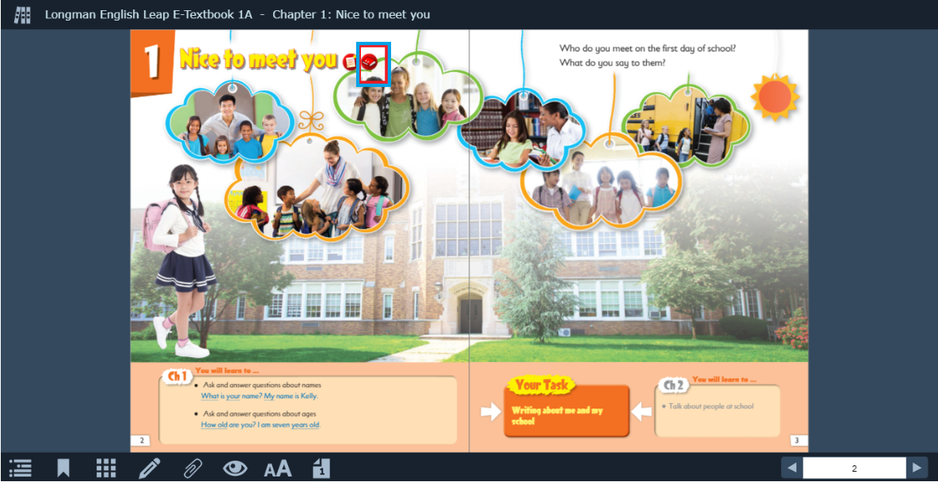



2. LEAP1A,P.4  
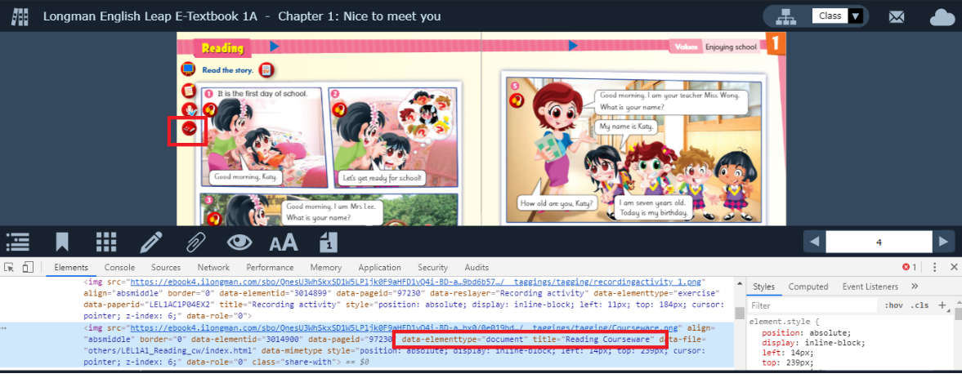

3. LEAP 1A,p.7  
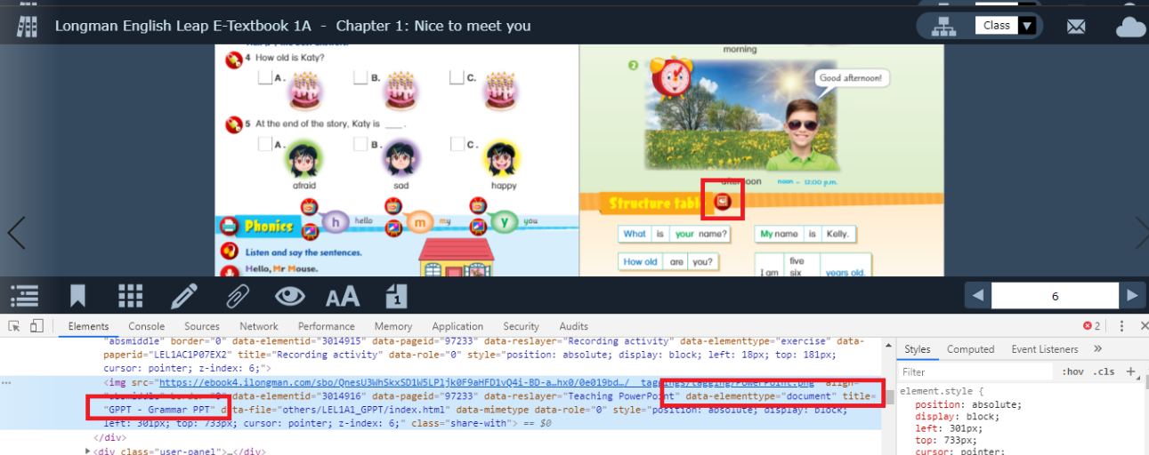

4. LEAP 1A,P.9

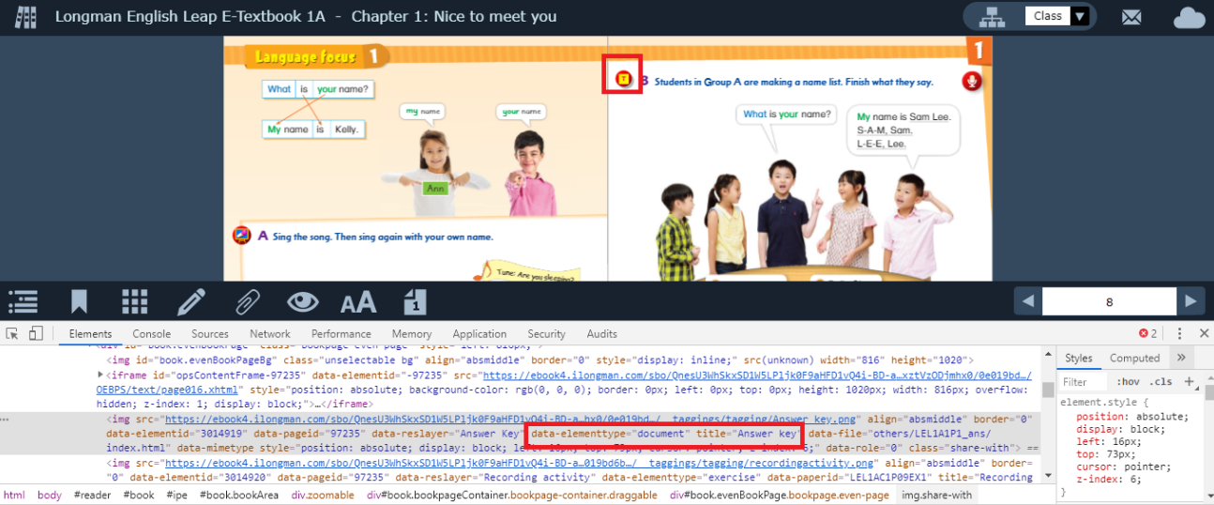

5.LEAP1A, P.12

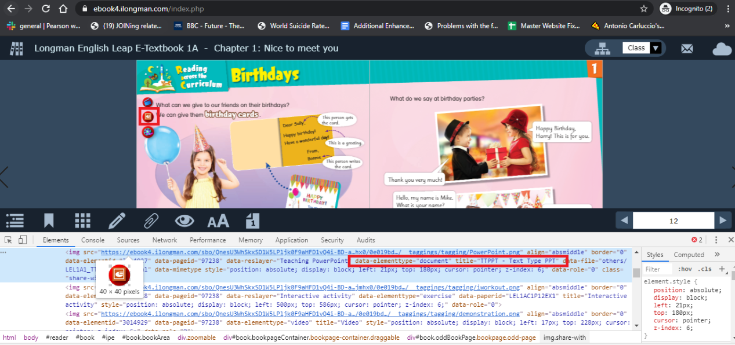

6.LEAP1A,P.24  
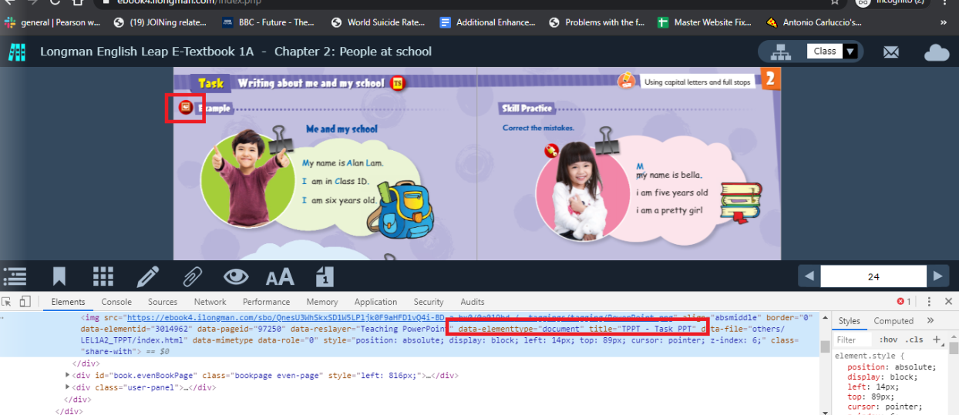

Spark 1A

1. Spark 1A, Blank 1

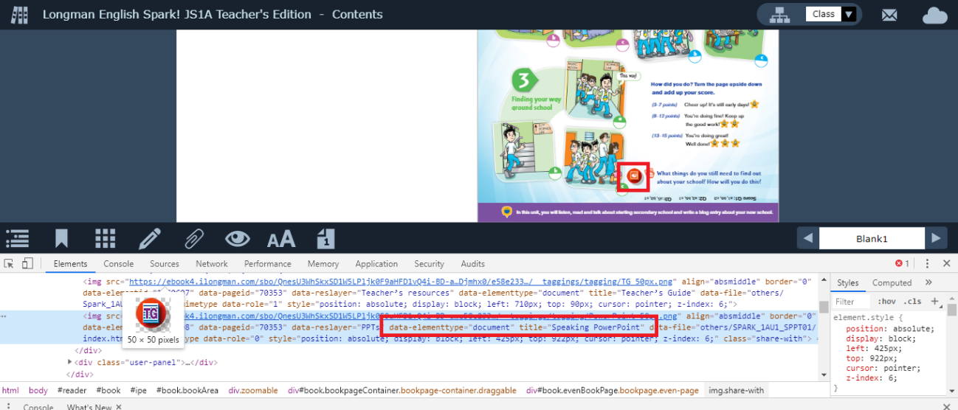

1. Spark 1A, P.2 (2 icons in this screencap)  
   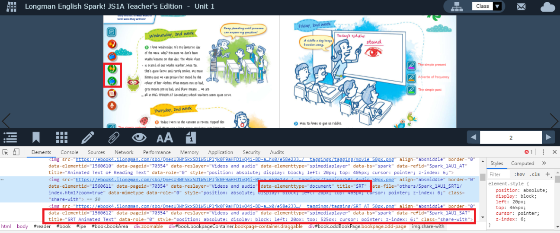
2. Spark 1A, P.4  
   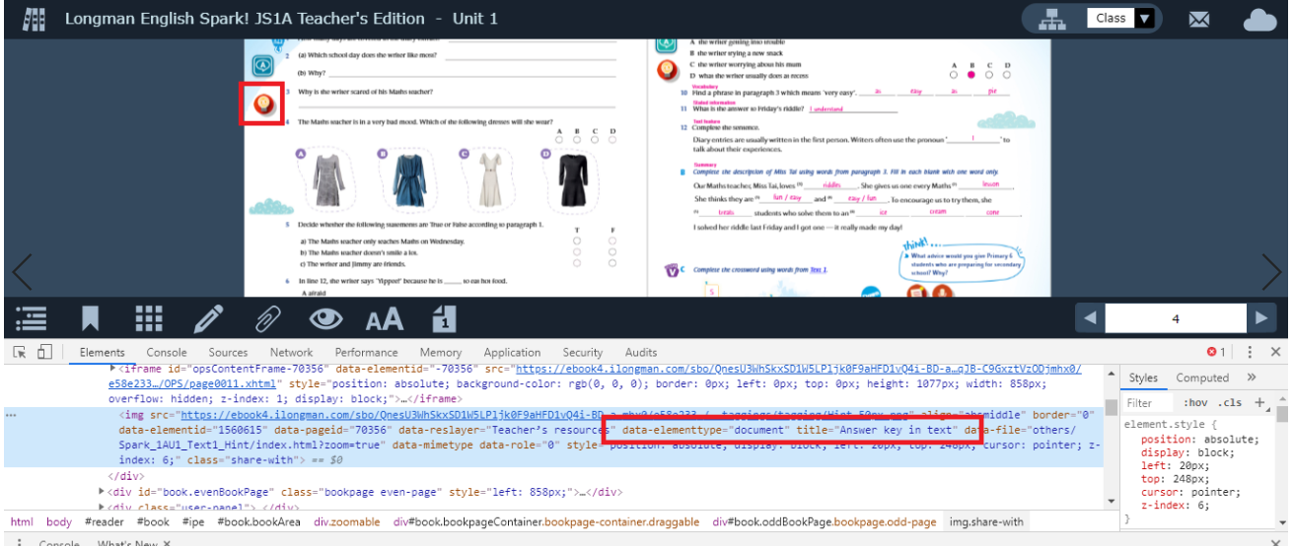
3. Spark 1A, P.10  
   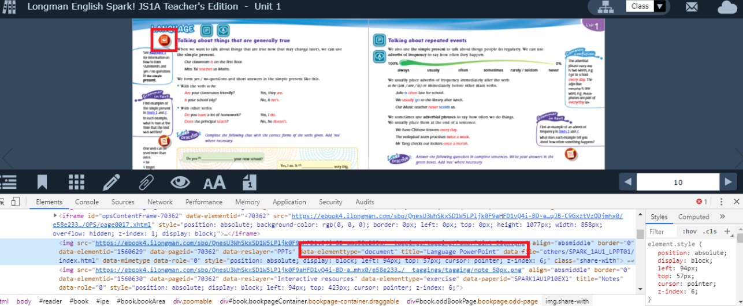
4. Spark 1A, P.12  
   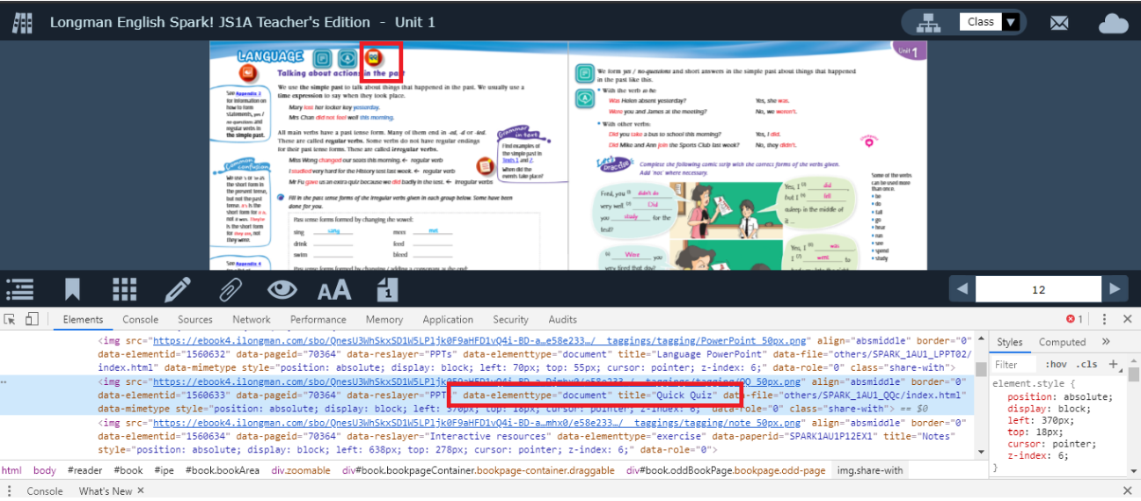
5. Spark 1A,P.18

